2nd Grade Units |  |  | Summary | Virtual Tours
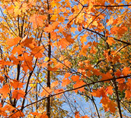 |  | Unit 1  A Season for Chapters | 6 week unit  Students focus on the beauty of language- in chapter books, informational texts, and poetry- all related to the four seasons. | Changing Seasons  http://vimeo.com/12367962  Time Elapsed Seasons  http://www.bing.com/videos/search?q=time+elapse+seasons&view=detail&mid=0ED87856931360B0DA150ED87856931360B0DA15&first=0  Snowflake Movies  http://www.its.caltech.edu/~atomic/snowcrystals/movies/movies.htm  Make Your Own Snowflakes  http://snowflakes.barkleyus.com/
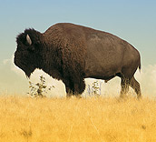 |  | Unit 2  The Wild West | 6 week unit  Students read literature set in the Wild West: chapter books, informational texts, songs, tall tales, and fairy tales. | Bill Pickett Rodeo  http://wn.com/Bill_Pickett#/videos  Annie Oakley  http://www.bing.com/videos/search?q=annie+oakley&view=detail&mid=20408FDB24656A6750CA20408FDB24656A6750CA&first=0  Wild Bill Hickock  http://wn.com/Bill_Hickok#/videos  George Catlin Pictures  http://www.bing.com/videos/search?q=george+catlin&view=detail&mid=B6FECA5AB261A05A627BB6FECA5AB261A05A627B&first=0
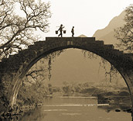 |  | Unit 3  Building Bridges with Unlikely Friends | 6 week unit  Students explore literal and figurative language through the theme of building bridges. | Bridges 3D Tour  http://www.google.com/gadgets/directory?synd=earth&preview=on&url=http://maps.google.com/maps/gx?oe%3Dutf-8%26output%3Dghapi%26q%3Dhttp%253A%252F%252Fearth.google.com%252Fgallery%252Fkmz%252Fbridges-3d-tour.kmz  Life in a Refugee Camp in Pakistan (Four Feet, Two Sandals)  http://www.bing.com/videos/search?q=refugee+camp+in+pakistan&view=detail&mid=189A3EFD793907A04B11189A3EFD793907A04B11&first=0  Silent Music  http://www.bing.com/videos/search?q=Calligraphy+in+Iraq&view=detail&mid=95A9F5BF526DBA0054E995A9F5BF526DBA0054E9&first=0
2nd Grade Units |  |  | Summary
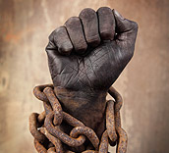 | Unit 4  A Long Journey to Freedom |  | 6 week unit  Students read informational text and fictionalized accounts of the African American journey to freedom. | Ruby Bridges  http://vimeo.com/20035098  Ballad of the Sit-ins  http://www.bing.com/videos/search?q=greensboro+sit+in&view=detail&mid=9D90F573E98CBA3125359D90F573E98CBA312535&first=0  Martin Luther King Jr. March on Washington  http://www.youtube.com/watch?v=IWcPz3TvtCg
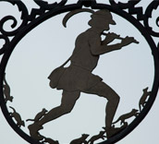 | Unit 5  Hand-Me-Down Tales from Around the World |  | 6 week unit  Students practice opinion and narrative writing as they read the poetry of Robert Louis Stevenson and a wide variety of legends, folktales, and informational books from around the world. | Robert Louis Stevenson  http://wn.com/Robert_Louis_Stevenson#/videos  Stone Soup  http://www.bing.com/videos/search?q=stone+soup&view=detail&mid=A17E64A580844A244CC0A17E64A580844A244CC0&first=0  Book Talk- Martina the Beautiful Cockroach  http://vimeo.com/31339024  Rudyard Kipling Speaking  http://www.bing.com/videos/search?q=rudyard+kipling&view=detail&mid=D9B9555F12B945CEE02FD9B9555F12B945CEE02F&first=0  Time Lapse- Bread Making  http://vimeo.com/21299019
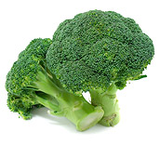 | Unit 6  Taking Care of Ourselves |  | 6 week unit  Students will enjoy a wide range of reading and practice informative/explanatory writing while studying human body systems. | The Skeletal System  http://www.bing.com/videos/search?q=human+body+muscles&view=detail&mid=D91DAD78CA426478A757D91DAD78CA426478A757&first=0  The Digestive System  http://www.bing.com/videos/search?q=the+digestive+system&view=detail&mid=B6AECE10736A17DC3290B6AECE10736A17DC3290&first=0  Hershey's Chocolate Factory  http://www.thehersheycompany.com/

